Family Ideas & Activities
Registered Charity: 1131388
Manor After School & Kids Klubs
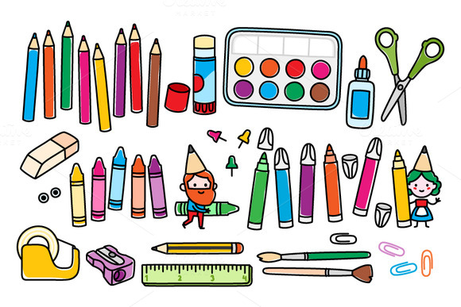
Stay Home, Stay Safe Edition
www.maskk.org.uk

We hope you enjoy this selection of ideas and activities. Our aim is that they’ll help you be creative by giving you some simple ideas that you can build on. Many of these ideas were found on the internet from various websites, along with some ideas from our team members. If you have any ideas of activities that we can include in our next edition please email them to letsplay@maskk.org.uk.
For those of you who are not familiar with MASKK and the work we do please visit our website to find out more, but in brief, we provide activities and services for children primarily aged 4 to 11 and their families. We provide after school & holiday playcare, short breaks on behalf of Sheffield City Council for children with special education needs and disabilities, along with community play activities including Active Kids, Stay & Plays and Family Picnics. In addition to this we support community events such as the Community Clean-ups, Community Bonfire and the Everyone’s Festival as well as providing volunteer opportunities for local people to gain skills and experience.
MASKK is a registered charity and relies on grants and donations to continue our work. If you have the means to offer a donation to help us continue our work, please visit our website and click “Donate Today”.
What’s included in this pack?
Keeping a Routine 3
Stay Active 4
What’s Your Favourite Meal? 5
A Homemade Crown 5
Thank You Bunting 5
All About Me 6
How Do I Feel? 7
Interview an Adult 8
Stay Home Word Search 9
Decorate Our Paths 10
Make a Door Handle Hanger 10
Creative with Junk 10
Make Your Own Funky ID 10
Making Moon Sand 11
Salt Dough 11
Treasure Hunt 11
Colouring 12
Word Search 13
Painting Nails 14
Have a go at Henna 14
Make a Pompom Run 14
Make your own Jigsaw 14
Weave a Fish 14

Keeping a Routine
Having a routine can help children manage their time and maintain a sense of normality. There are many ways you can do this including a simple list of activities for the day, ticking them off as you go or using charts. The schedule below, found on the internet, uses images to support children with different communication methods.
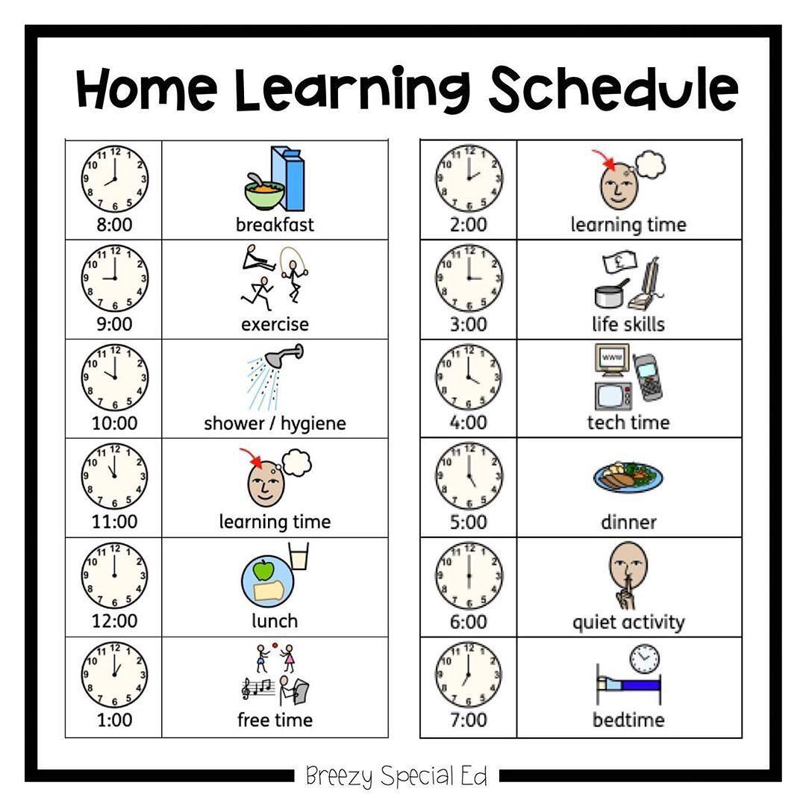
If you have access to the internet and a printer then check out the Sheffield Children’s Hospital link below, which gives you more templates that you can download and use too. https://www.sheffieldchildrens.nhs.uk/patients-and-parents/coronavirus-resources-for-children-and-families/

Stay Active
Staying physically active is an important way to stay healthy. It effects not only your physical health but your mental health and wellbeing too. It doesn’t have to require long runs or fancy equipment either. If you have access to YouTube then Joe Wicks has been posting a daily video at 9am you can follow in the comfort of your own room.
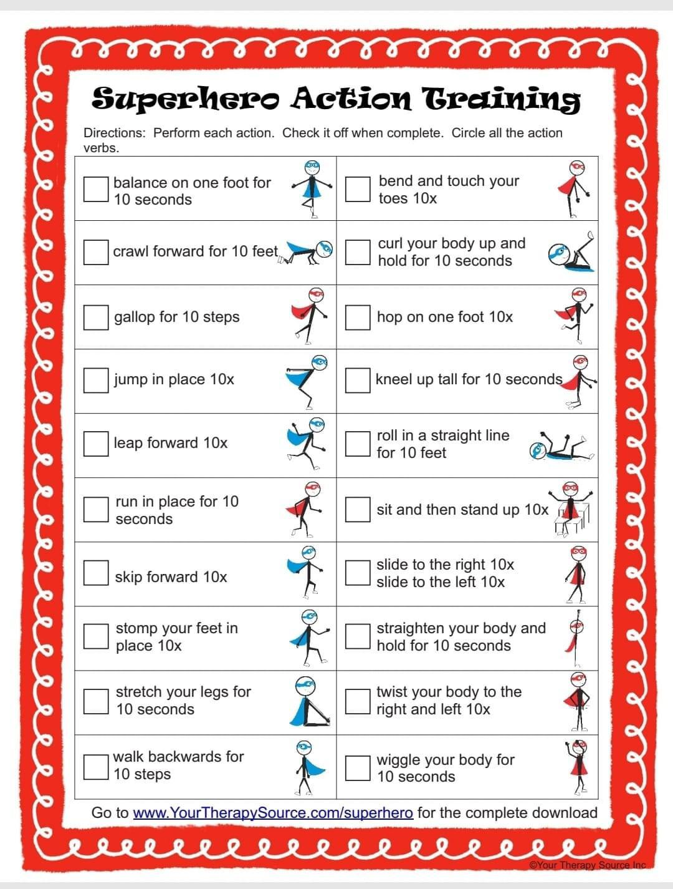
Alternatively, simple ideas like below can help guide you.

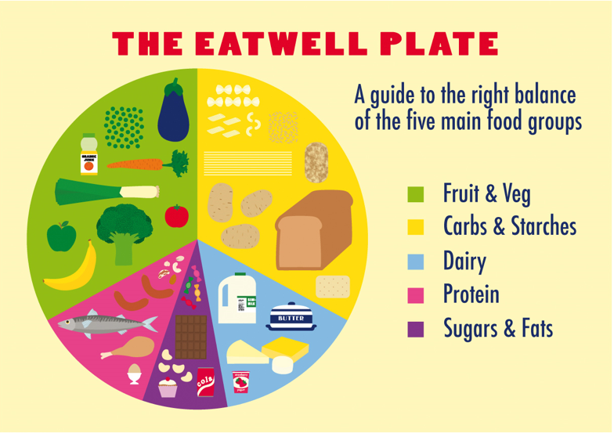
What’s Your Favourite Meal?
Use a paper plate (or cut out a circle if you don’t have one) and draw your favourite meal.
Maybe use tissue paper or other bits and bobs to stick on to represent the food. Extend it by having a chat at the same time about what makes a healthy meal and balanced diet.
Did you know in the Apple and Google App store you can download “Change4Life Smart Recipes”, which will help you create some great meals.
Cooking together can be fun and helps teach great skills for life, why not prepare your favourite meal together and take some photos to send to family members.

A Homemade Crown
Cut a piece of A4 paper or card into equal sized strips, stick them together with sticky tape, making it into a round crown. Make it more royal by cutting triangles into it too.
Use pencils, crayons or paints to decorate it, sticking other items on too.
Sweet wrappers and tinfoil make great shiny jewels!
Did you know Mary Queen of Scots was held captive in the Manor? https://sheffieldmanorlodge.org/ holds events and have a centre where you can learn more, and people living in S2 can take along proof of address to claim a FREE annual pass.

Thank You Bunting
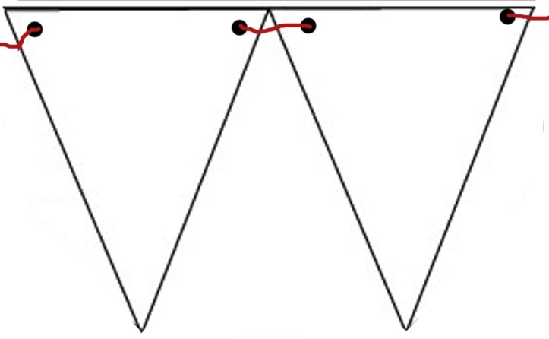
Cut paper or card into large triangles. Use a hole puncher to put two holes in the top and ribbon or string to connect them. On each triangle think of a job that helps people during this time. This could be NHS roles including nurses, doctors, paramedics etc or why not think of others too? What about volunteers at the local food bank who are helping to provide food for vulnerable people? Or the shop keeper who is keeping their shelves full and shop open so we can buy food.
Why not put it up on Thursdays at 8pm when we go out to clap and thank all the people working hard to keep us safe.

All About Me
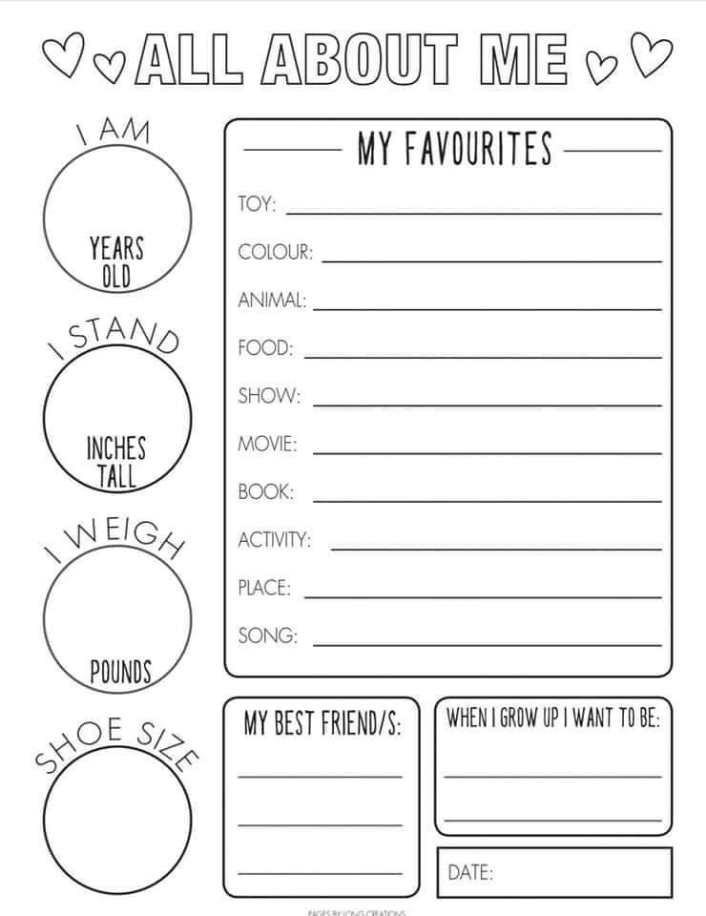
Reflect on who you are today. Maybe put it somewhere safe and look back at it again on a later date.

How Do I Feel?
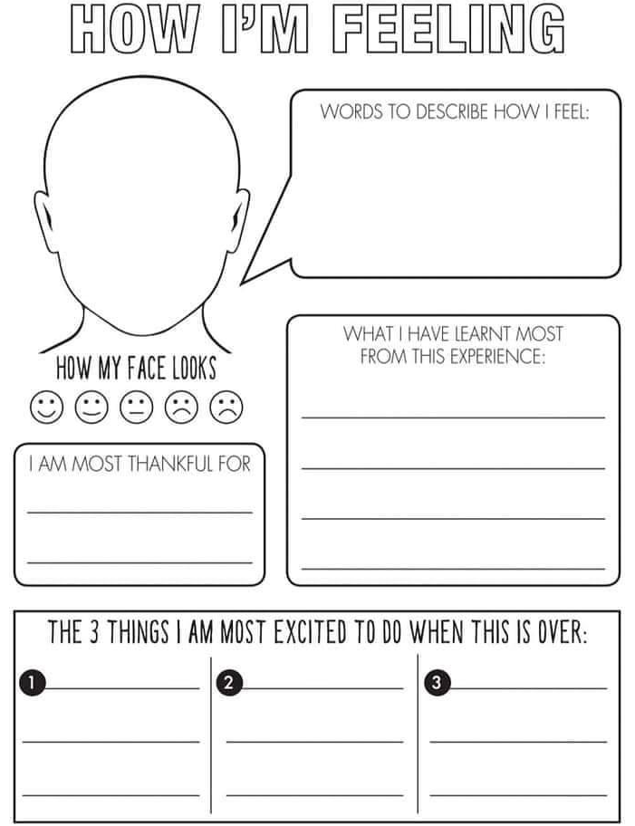
Thinking about your feelings and sharing them is a great way to express ourselves in difficult times.

Interview an Adult
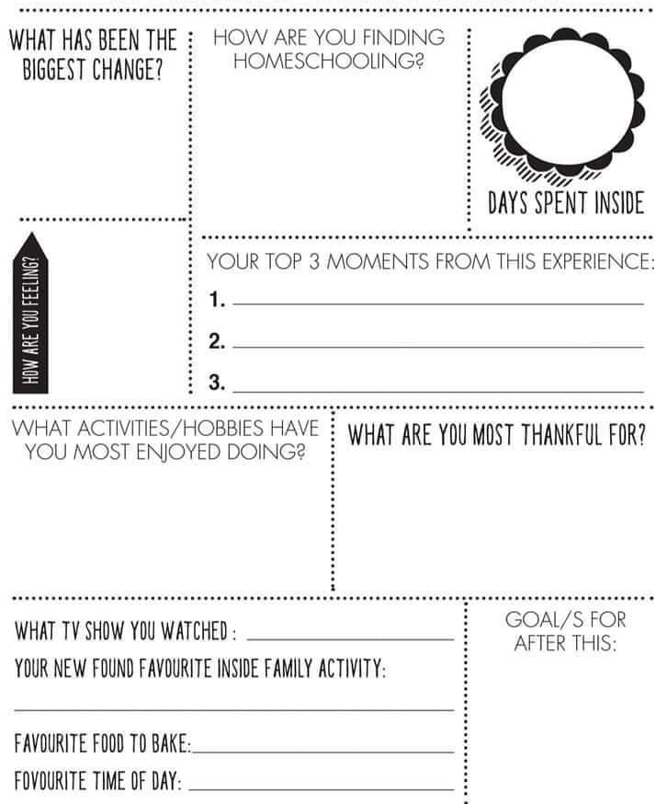
It’s a difficult time for children and adults. It’s great to take time to think about how the current situation is impacting on your house as a whole.

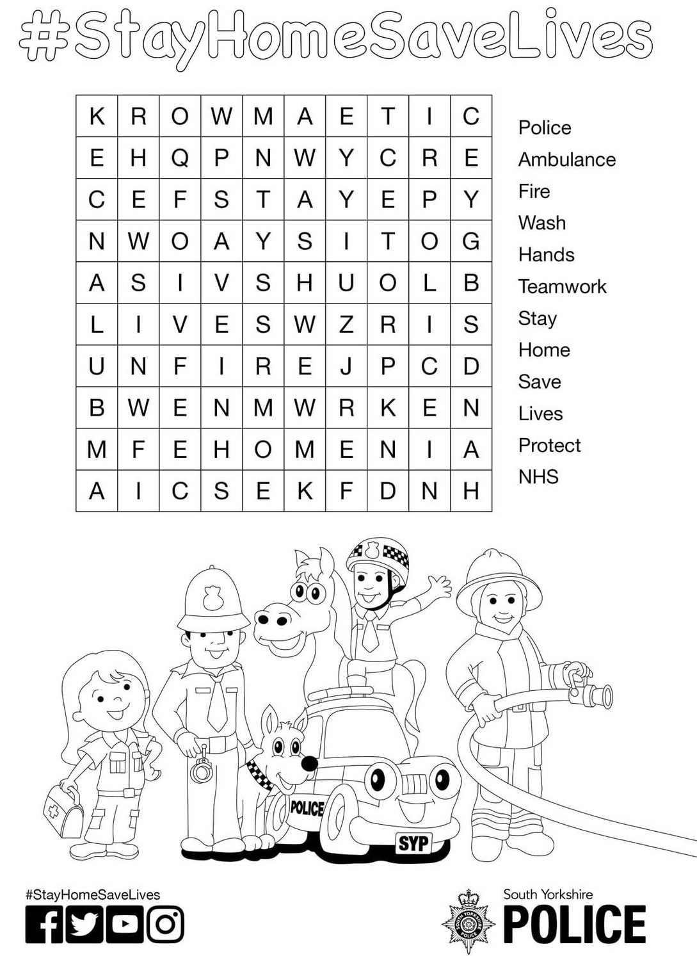
Stay Home Word Search

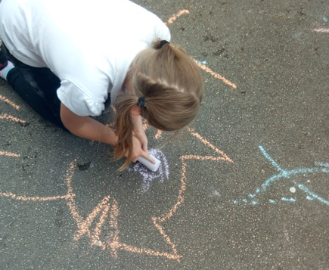
Decorate Our Paths
Take some chalk outside to decorate the paths and brighten up our world.
Maybe leave a nice message for the postal worker, or draw positive words using big bold letters.

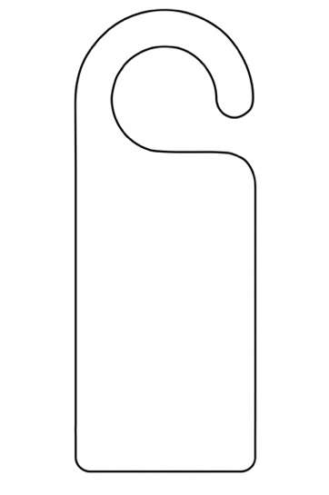
Make a Door Handle Hanger
Cut a piece of card in the shape shown, making it a big as you like. Cereal boxes are great for this! Then decorate using your imagination by colouring, writing or sticking.
Why not make extra ones for your family too.

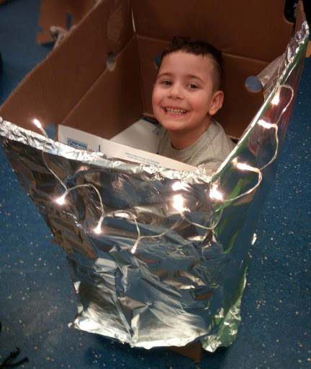
Creative with Junk
Empty cardboard boxes, plastic milk bottles, yogurt pots and much more can be used to spend hours being creative. Just add some sticky tape and bits & bobs and off you go! Use your imagination and see where it takes you, perhaps a space station looking down on Earth or a super-fast car! The bigger the boxes the more possibilities too.
If you’ve got the space to save it, this can become a project that grows, making extra pieces to add on or using it to develop their play space. Add some old sheets, battery fairy lights from your Christmas box or an old plastic bowl to be a helmet. You can visit https://www.playscotland.org/parents-families/loose-parts-play/ for more ideas.
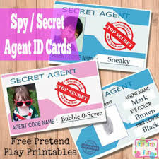

Make Your Own Funky ID
Using a blank sticker, or piece of paper, make your own ID card. Draw your own face, give yourself a cool nick name and why not think of your job title in your house? Are you the giggle monster, pot washer, chatter box, chief mess maker or are you a secret agent?
Why not make them for your whole family?

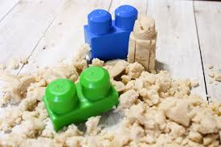
Making Moon Sand
The recipe is simple: 8 parts* of flour & 1 part of oil (we used baby oil but coconut oil would also work). Mix it up really well until all of the oil is incorporated into the flour. It will still look like flour (albeit full of teeny tiny lumps from the bits of oil), but it is mouldable just like Moon Sand!
Add a drop of essential oil or food colouring to make it more interesting too.

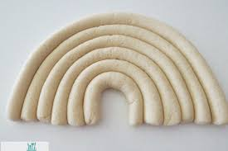
Salt Dough
Salt dough is a simple way to have fun making a mess whilst being creative. You can leave it to air dry or for faster results oven bake. Bake the salt dough in a preheated oven at 150°c / Gas Mark 2 for approximately 3 hours or until they are completely dry.
The recipe is simple: 2 parts* of flour, 1 part salt, 1 part warm water (not hot).
In a bowl mix the salt and water together until dissolved. Gradually add the flour, mixing in carefully to avoid lumps. Once it feels like a nice dough you can roll, cut, shape.
If you have glitter you can stir in a generous amount to make your final product shine.
Once you’ve got the dough you can use your imagination as to what to make, maybe a hand print, your initials or ornaments of your choosing. Once its dry you can also paint it too.
*measuring spoons, small cups etc just using the same size item for the flour and other ingredients to help measure it correctly.

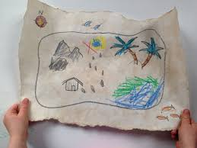
Treasure Hunt
Draw a map of your house or garden, include your furniture, cupboards etc. Then go and hide some important treasure, maybe a sweet treat and place an x on your map.
Give the map to someone in your family and see if they can follow your map to find the hidden treasure.
While making your map, have a quick think about your emergency escape plan, do you know where the nearest exit from your bedroom is?

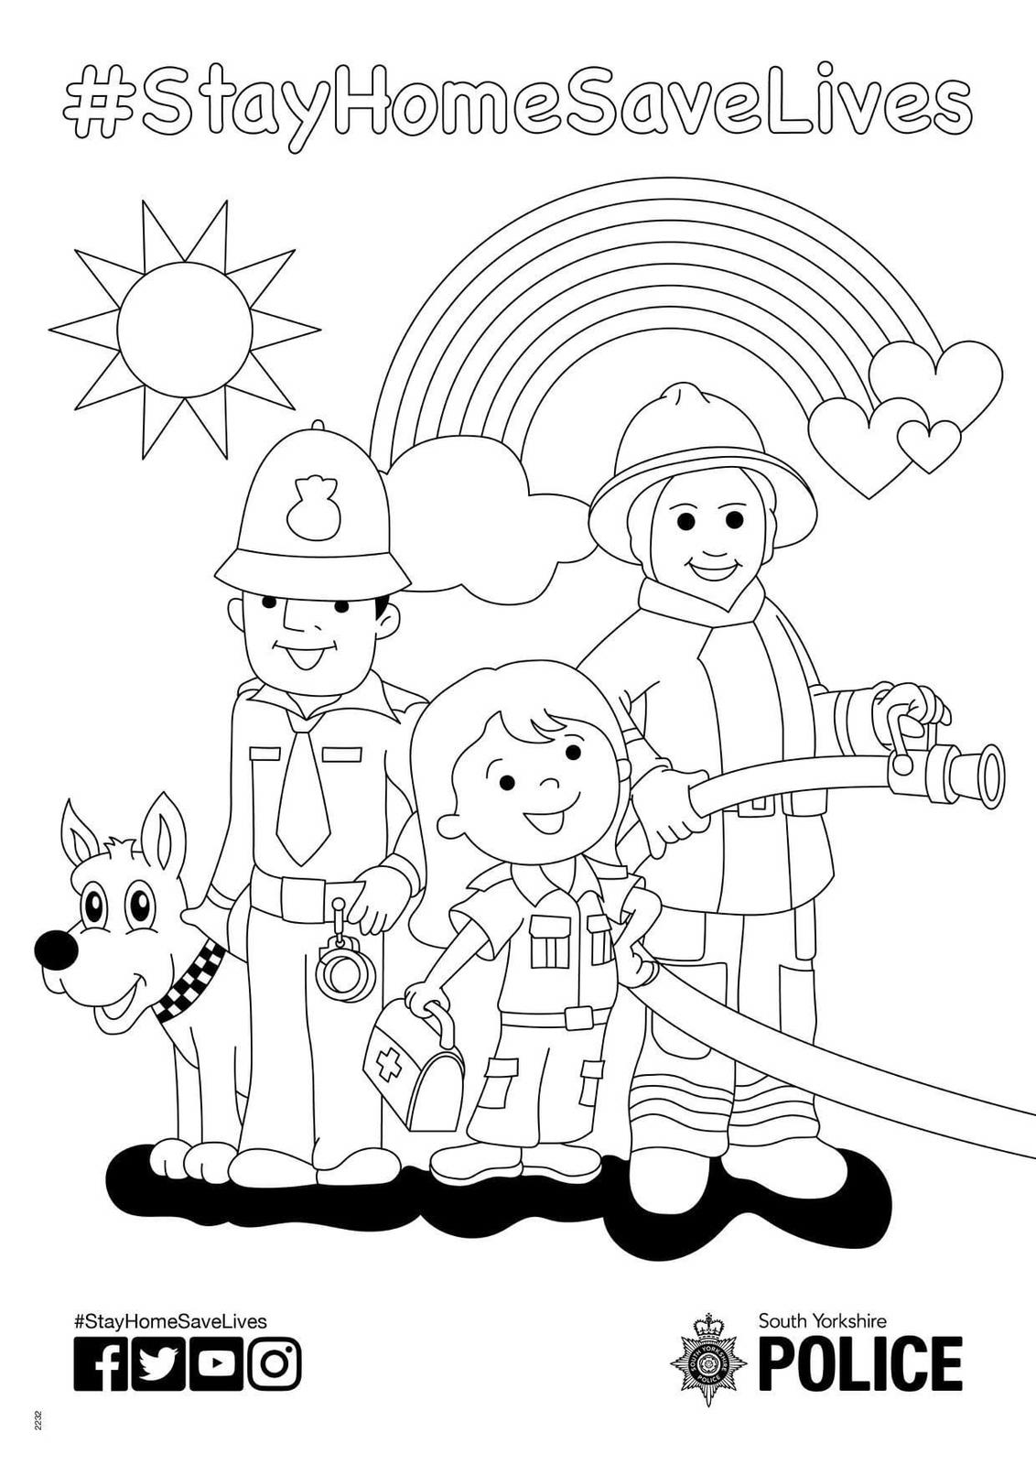
Colouring

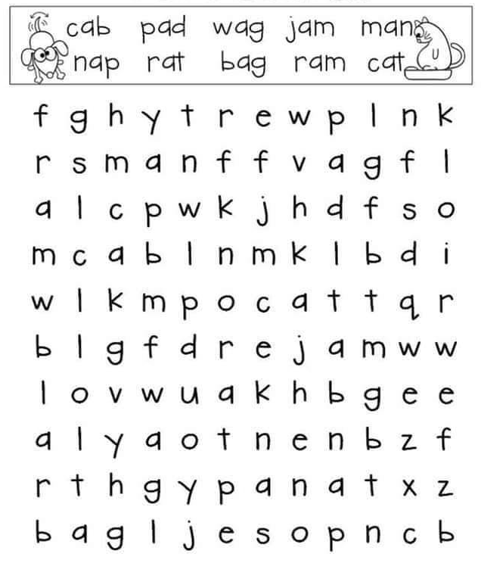
Word Search

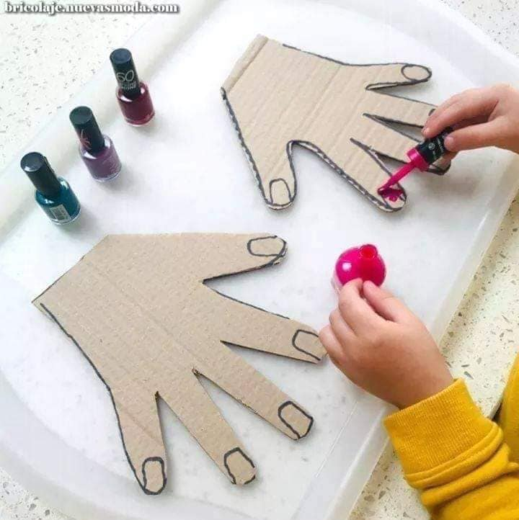
Painting Nails
Painting nails can be relaxing, but messy. Why not cut out a carboard hand and paint its nails? Even using regular water paints instead of nail varnish.
Cut out extra-large hands to help younger children.

Have a go at Henna
Using a card hand, try out Henna designs using pencils or pens. There are lots of ideas on the internet to help.
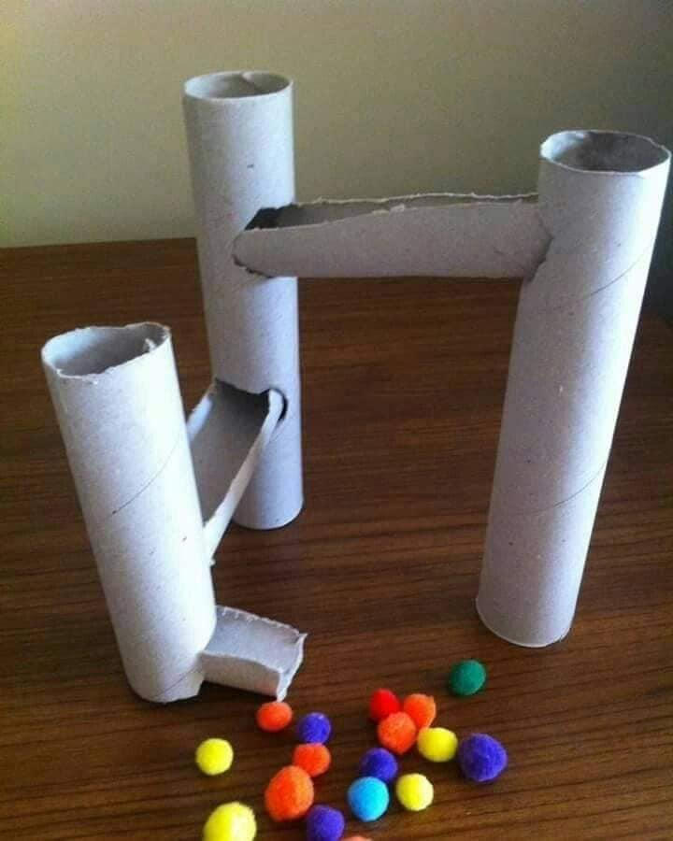

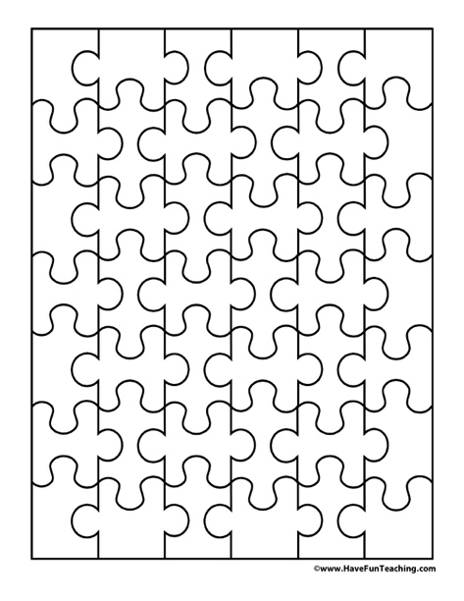
Make a Pompom Run
Using card tubes you can make your own marble or pompom run. How many tubes can you collect and how big can you make the run.

Make your own Jigsaw
Create your own picture, using pens, pencils or paints and then carefully cut it up and then you can make it again and again. There are some template available to help too.

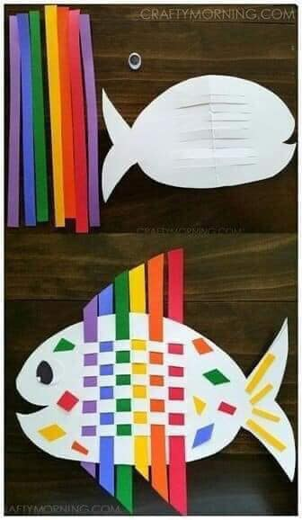
Weave a Fish
Cut out a fish, fold in half to cut the lines across the middle. You can paint or colour the fish in first too to make it more unique before weaving strips of paper through it.
Don’t have coloured paper? Perhaps cut up strips of junk mail you’ve received to make a mismatch pattern.

Everyone at MASKK hope these activities help you spend quality time together. Follow us on Facebook for more ideas too.

Manor Word Search
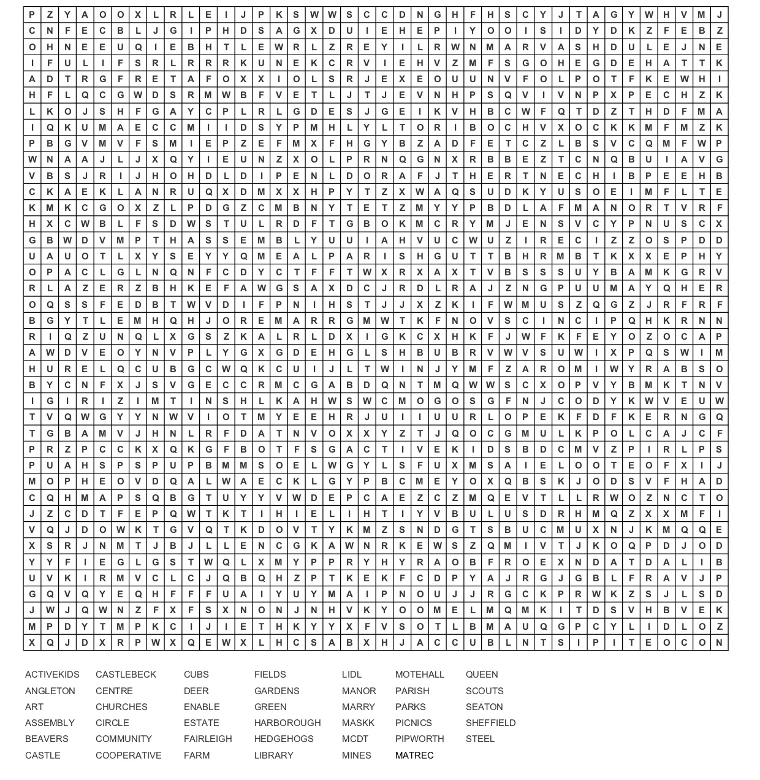
Can you find the words below associated with our local area?
Did you know you can make your own word searches on the internet? We made this at http://puzzlemaker.discoveryeducation.com/
Want to make one and send it to us to use in future editions? Email it to letsplay@maskk.rog.uk.

