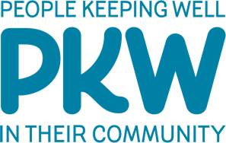
Recipes & Activities
Produced by www.maskk.org.uk
Registered Charity: 1131388

This Christmas Holiday we’ve put together this little booklet to help inspire you to get creative. These ideas and activities are from various websites and supplied to you for your personal use. We’d love to see photos of your creations though, if putting a photo on social media please put #OurCommunityChristmas and we’ll be able to see your wonderful creations.

If you want to try out the recipes you will need the following items, available in most shops and makes four meals for four people. Double some of the items to make more.

3 large potatoes
2 leeks
2 vegetable stock cubes
4 onions
1 pack of wholemeal pitta bread
1 tin of kidney beans
1 carrot
1 small bag plain flour
1 garlic bulb
1 tin of chopped tomatoes
1 tin of butterbeans
1 bag of rice
1 bag of macaroni pasta
Vegetable/sunflower oil
1 x tin of garden peas or bag of frozen peas
1 jar of pesto

For the craft bits you will need:
Scissors
A glue stick
Colouring pencils or pens

What’s included in this pack?
Useful Numbers 3
Leek and Potato Soup 4
Macaroni Pesto Peas 5
Tomato and Butterbean Risotto 6
Carrot and Kidney Bean Burgers with Wedges 7
A random fact about leeks… 8
A Winter Walk 8
Recycling this Christmas 8
Word Search 9
Plants in Jars 10
3D Cone Bobble Head Elf 11
Christmas Wreath Decoration 13
Make A Christmas Tree 15
16

Useful Numbers
S2 Foodbank: www.s2foodbank.org.uk
Free School Meal Vouchers: 0114 2734567
NHS (non-emergency medical helpline): 111
Samaritans 24 hour helpline for people in crisis and distress: 0114 2767277
Citizens Advice: 03444 113 111
National Grid for Gas Emergency: 0800 111 999
Fly tipping You can report it online to the Council. Via https://www.sheffield.gov.uk/form/roads-pavements/report-fly-tipping or by telephone on 0114 273 4567.

Support available from Manor and Castle Development Trust:
There is more to learning than doing homework! Learning something new could be for you in 2021.
Courses for Adults are a great way to meet new people, increase your self-confidence, find new hobbies and increase your job prospects.
For more information or to sign up contact:
Lea, Learning Champion on 07814 036510 OR MCDT Office 0114 278 9999
lealapautre@manorandcastle.org.uk OR cherylmckeown@manorandcastle.org.uk

Employment Support (job searches, CV’s, interview prep): 0114 2655145
Advocacy Team (Health Trainers, access to physical fitness, 1:1 support): 0114 2655145
To find out about what else MCDT is doing, please follow us on Facebook: https://www.facebook.com/MCDTLtd
Or visit www.manorandcastle.org.uk

Leek and Potato Soup
Ingredients (serves 4)
- 2 leeks
- 1 large potato
- 1 vegetable stock cube
- 1 onion
- 1 tbsp vegetable or sunflower oil
Method
- Chop and slice the onion and leeks.

- Heat the oil in a large pan and add the onion and leeks to the pan.
Cook for 5 minutes until they have started to soften.

- Dice the potato into cubes and add to the pan.
Cook for another few minutes.

- Add 1.2 litres/2 pints of water and the vegetable stock cube to the pan and bring to the boil.

- Season with some pepper and let it simmer until the vegetables are soft.

- Whizz with a hand blender or leave chunky and enjoy!
Top tip: Make some tasty croutons to go on top by chopping up the crust of a loaf of bread, popping it on a baking tray and drizzling with a bit of oil. Either bake for 5-10 minutes or fry in a pan until crunchy and sprinkle on top of the hot soup!

Macaroni Pesto Peas
Ingredients (Serves 4) Adapted from Jack Monroes recipe ‘Macaroni Peas’
- 300g macaroni or other pasta
- 2 garlic cloves
- 1 onion
- 300g tinned or frozen peas
- 2 tablespoons pesto
- 1 teaspoon oil
Method
- Bring a pan of water to the boil and add the pasta.
Cook according to the packet instructions, usually around 8 – 10 minutes.

- Peel and finely chop the onion and garlic.

- Heat the oil in a pan and cook the onion and garlic on a low heat for 5 minutes or until soft.

- Add the peas and pesto and stir together.

- Drain the pasta and add to the pea and pesto sauce. Mix and serve!
Top tip: If you want to add some more veg, mushrooms go nicely with this as does ham or chicken for those that would prefer something meatier.
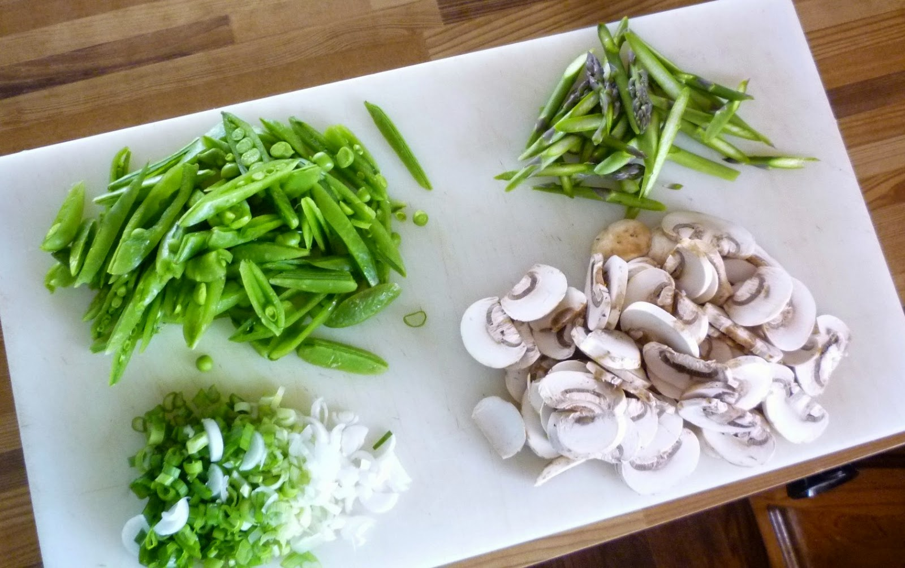

Tomato and Butterbean Risotto

Ingredients (Serves 4)
- 1 tin of chopped tomatoes
- 1 tin of butterbeans
- 1 onion
- 2 garlic cloves (or more if you like it garlicky!)
- 400g rice
- 1 vegetable stock cube
- 1 tablespoon vegetable/sunflower oil
Method
- Heat the oil in a large pan. Peel and slice the onion and garlic and add to the pan. Fry on a medium heat for 5 minutes until the onion starts to soften.

- Pour in the rice and stir for a minute. Add the tin of chopped tomatoes. Fill the empty can with water and add to the pan. Crumble in the vegetable stock cube.

- Drain and add the butterbeans and then simmer on a medium heat.

- Continue adding water a bit at a time until the rice is cooked through – be careful not to add too much water. Keep stirring to stop it from sticking to the bottom of the pan.

- It’s ready once the rice is cooked, and the risotto should be a thick soupy texture. Serve with some grated cheese on top!
Top tip: If you don’t like butterbeans you can replace them with any other beans, or with chicken. They are a fantastic source of protein and fibre so give them a go if you haven’t tried them before!

Carrot and Kidney Bean Burgers with Wedges
Ingredients (Serves 4) *Adapted from Jack Monroes recipe ‘Carrot and Kidney Bean Burgers’
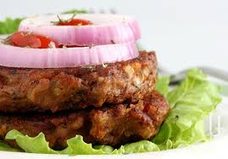
- 1 tin of kidney beans in water
- 1 pack of wholemeal pitta breads
or burger buns
- 2 large potatoes
- 1 onion
- 1 carrot
- 2 tablespoons vegetable/sunflower oil
- 1 heaped teaspoon flour
- 1 teaspoon cumin
Method
To make the wedges…
- Preheat the oven to 180ºC.

- Wash the potatoes and slice them into wedges. Place them on a baking tray and then drizzle with 1 tablespoon of oil and a bit of salt and pepper.

- Roast in the oven for around 30-40 minutes until soft on the inside and crispy on the outside.
To make the burgers…
- Drain and rinse the kidney beans. Put them in a pan, cover with water and boil for 10 minutes to soften.

- Finely chop the onion and grate the carrot. Add to a pan along with the cumin and a splash of oil and cook on a low heat until soft.

- When the kidney beans are soft, drain and add them to the onion and carrot. Take off the heat and mash together with a potato masher or fork. Stir in the flour.

- Heat 1 tablespoon of oil in a frying pan on a medium heat and rub a bit of flour on your hands. Scoop up a quarter of the burger mixture and roll into a ball. Make three more balls with the remaining mixture. Place one in the oil and flatten gently with a fork to make the burger shape. If you can fit them in then cook all the burgers at once, otherwise do them in batches.

Cook for around 5 minutes on each side and then put inside a toasted pitta bread. Serve with salad and wedges!

A random fact about leeks…
Ancient Egyptians cultivated and consumed leek.
Great Roman emperor Nero was also known as "Porophagus" or "leek eater". He regularly consumed this vegetable due to belief that leek improves singing capacities.
According to the legend, troops of British king Cadwallader used leek (tucked in the helmets) to quickly identify friends from the enemies on the battle field. This unusual tactic saved many lives and resulted in victory of British army over the Saxons.

A Winter Walk
Going out for a walk is a simple way to get moving and spend some time outdoors. Having a reason to go can make the journey more fun too.
Why not go for a walk to a local green space or park and tick when you find the following items:

A Robin | A Twig | The Moon
Some Christmas Lights | A Santa  (maybe an inflatable one) | Some winter berries for the birds

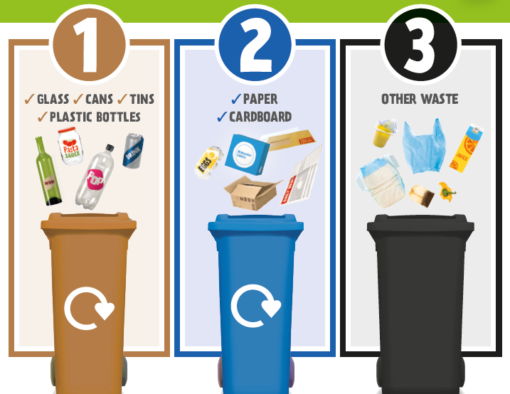
Recycling this Christmas
During Christmas there are lots of ways we can recycle, either through proper disposal or reusing.
Your pesto jar will be perfect for one of the projects in the booklet, and sweet wrapper and old wrapping paper make great shiny and colourful pieces to stick and be creative with.
Not got black paint? Use the black card or paper left after making the wings to cover the tube.

Why not put a small hole in the back of the bat body to thread string through to hand your bat.

For more information about waste and recycling in Sheffield visit the website below. Did you know Sheffield has a bulky waste collection too, that is free for some and low cost for everyone else. https://www.sheffield.gov.uk/home/bins-recycling-services/your-bins

