Family Ideas & Activities
Registered Charity: 1131388
Manor After School & Kids Klubs
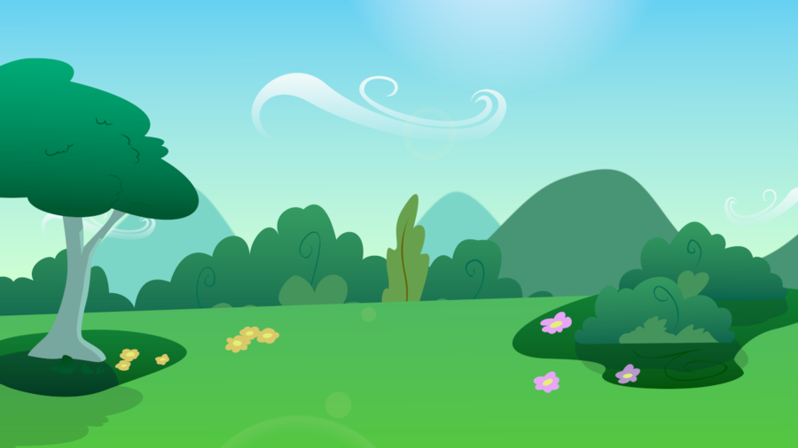
Let’s Get Outside Edition
www.maskk.org.uk

Like our other editions, some of these ideas were found on the internet from various websites, along with some ideas from our team members. If you have any ideas of activities that we can include in our next edition please email them to letsplay@maskk.org.uk. We hope they’ll help inspire your imaginations and provide opportunities to spend quality time together.
These activities were put together in May 2020, an unusual time for us all and during the implementation of social distancing rules. Please ensure you are following the latest Government advise when leaving your home to help keep everyone safe.

For those of you who are not familiar with MASKK and the work we do please visit our website to find out more, but in brief, we provide activities and services for children primarily aged 4 to 11 and their families.
MASKK is a registered charity and relies on grants and donations to continue our work. If you have the means to offer a donation to help us continue our work, please visit our website and click “Donate Today”.
What’s included in this pack?
Tree Trolls 3
Garden Naughts and Crosses 3
Wooden Medallion 3
Wooden photo frame 3
Make a bug hotel 4
Garden Word Search 5
Fairy Tepee 6
Outdoor Bunting 6
Dream Catchers 7
Kite Making 7
Alphabet Hunt 7
Dream Garden 8

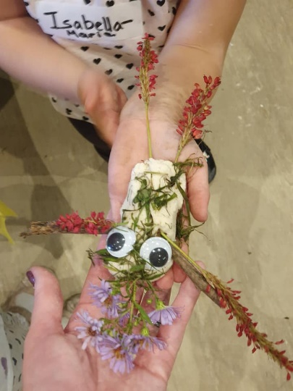
Tree Trolls
Make a fun Tree Troll to live in a local tree!
You’ll need some clay and then search your garden or enjoy a walk to find some: sticks, twigs, flowers, leaves and small stones. If you have some googly eyes even better!
Using the clay to make the base of the troll and stick the items you have found into the clay.
If you don’t have clay then salt dough or a nice pile of mud work well too

Garden Naughts and Crosses
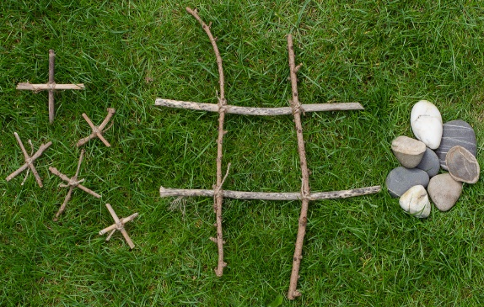
Find some sticks, large and small, and matching other items, perhaps pebbles and leaves.
Lay the large sticks out to make a grid and use the other items to be your noughts or your crosses. Using some string to tie to sticks together makes great crosses.
Alternatively use an old cardboard box, cut out some large counters and paint or draw your noughts or crosses.
Save the game after to be able to play again and again.

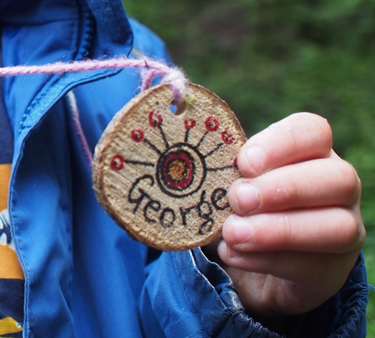
Wooden Medallion
Find a piece of wood and put a hole throw it for ribbon or string. Then decorate to create an awesome medallion to wear when out in the woods!
Decorate with pens, paints, or whatever you can find outside.
What happens if you rub a green leaf on the wood?

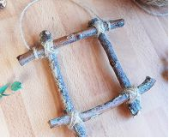
Wooden photo frame
All you need is sticks and string.
Collect four sticks of a similar size and tie them together at all four corners. Making it very tight!

Tips: You can add glitter and gems. You can also use lolly pop sticks or straws to create these giving children lots of fun doing photo shoots.

You can then print off a photo and stick it on to the sticks a great homemade gift for family and friends to remind them you are thinking about them.

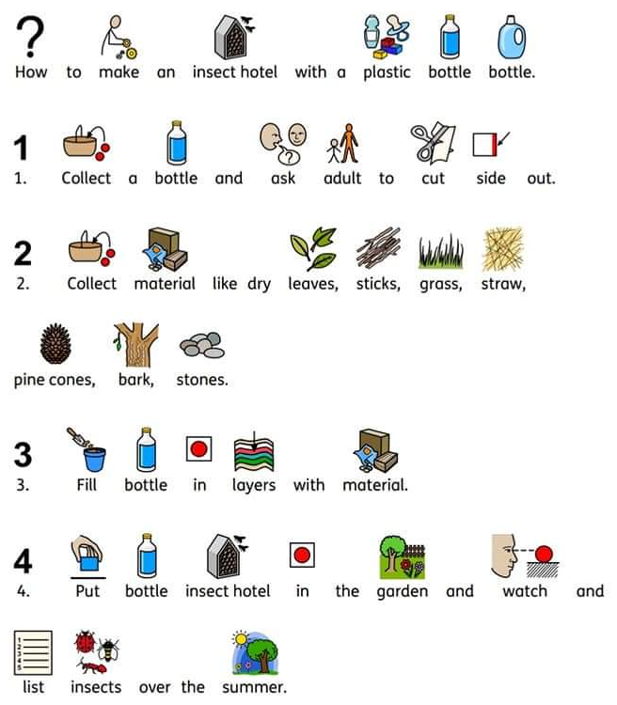
Make a bug hotel
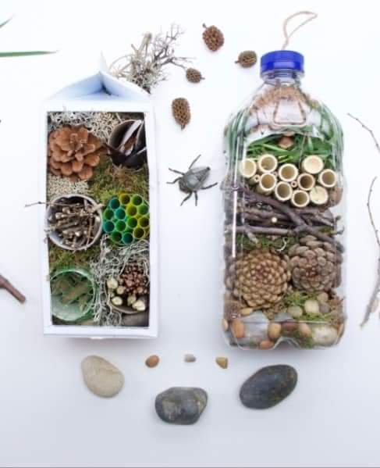

Why not take some time to draw or paint what insects you see, or use your imagination to create your own super bug!

If you have a camera perhaps also practice taking close up shots to show the bugs enjoying your awesome hotel

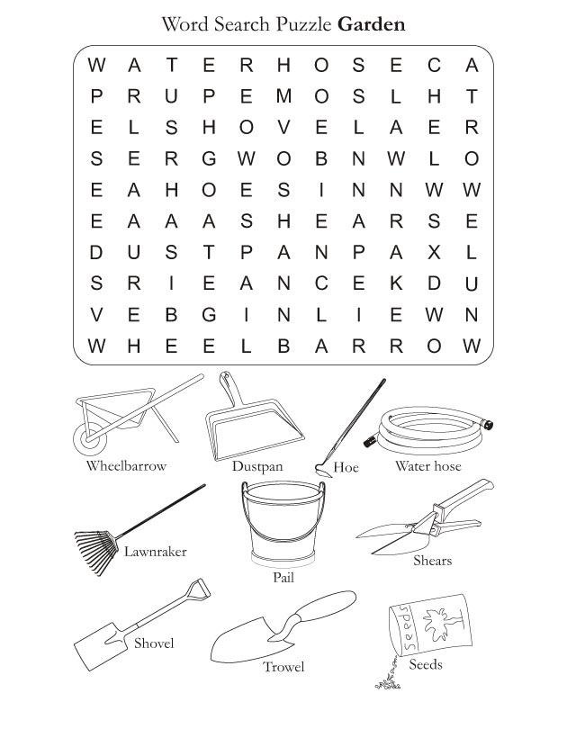
Garden Word Search

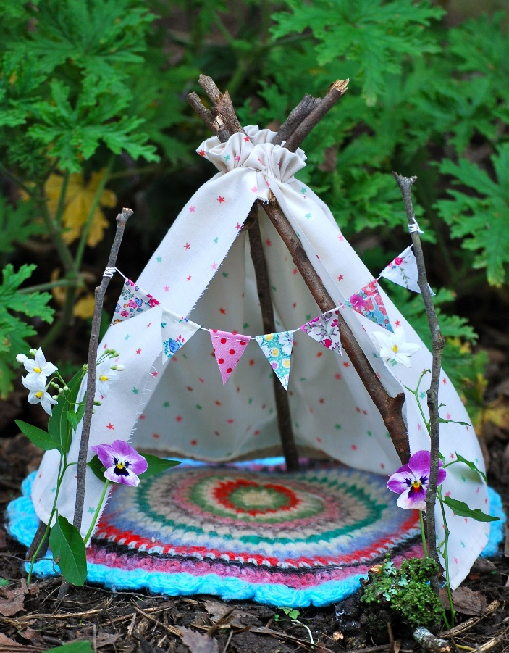
Fairy Tepee
Fun activity for all and something to prompt your imagination! What fairies might want to visit?
Why not create a story about your tepee and the fairies that live there.
You will need: Sticks, string, materials to make a cover, natural materials like leaves, flowers twigs to finish off the look.
Tie 3 sticks together at the top to form a tripod.
Then cover with a choice of material and attach it to the top of your Tepee.
Bild it up and decorate to your desired choice.

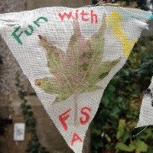
Outdoor Bunting
This is fun and easy to make, younger children will need supervision though.
You will need: Plain material (maybe an old cut up pillowcase or t-shirt), leaves, flowers, colouring pens to decorate, string, hammer.
How to make: Find some colourful damp or dry leaves, placing them under your material making sure you have something hard underneath example on the outside floor or wooden logs.
Use your hammer and gently tap it onto the material, to start with you might have to apply more pressure depending on what you are printing.
When using your hammer always make sure it is safe and no one is to close before you start.
You will then see the imprint of the leaves and flowers transfer onto you bunting.
Put two holes in at the top to be able to thread the string through, do this as many times as you want to create your bunting.
Tip: You can make these as gifts, celebrations or to add to something already created example a fairy Tepee

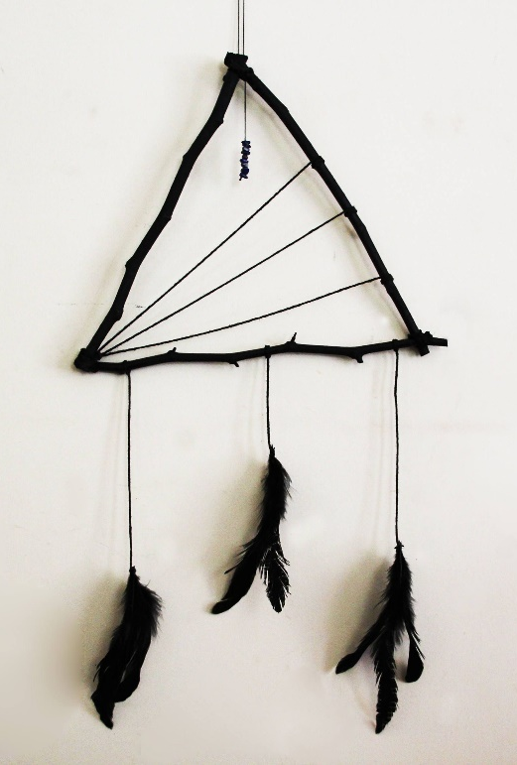
Dream Catchers
You will need: sticks, string or wool, feathers, beads to decorate.
To create your dream catcher: Tie sticks together firmly to form a triangle or square the tighter the better so it is secure. Attach wool and tie it at one of the corners, move the wool weaving it in and out of the shape until you have your pattern, tying it off at the ends.
Add feathers and beads at the end of your dream catcher to decorate it.
Tip: Adding beads will give it extra weight to support it better. You can also change your wool colours to make it more colourful.

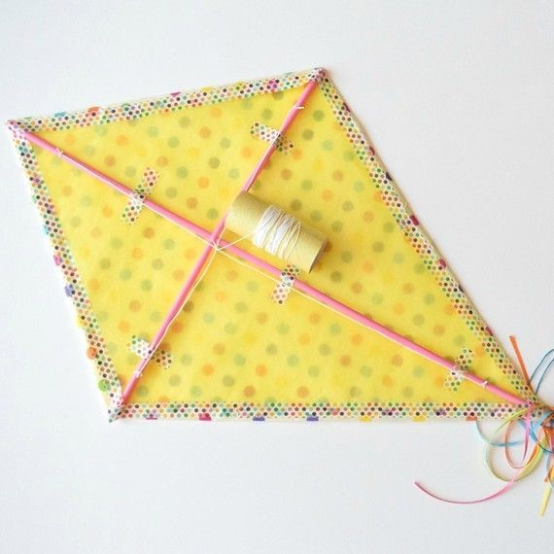
Kite Making
You will need: straws or thin garden sticks, string, sticky take, scissors, light material or plastic bags.
How to put it together: decorate your material or bag.
Cut you material to the size of your straws or stick stretching the material out so it is nice and tight.
Tape the sticks in place so they are secure but remember not to use too much tape as this will make it heavier.
Attach colourful ribbon to the end along with your string to make it brighter.
You are now ready to see if you can fly your kite!

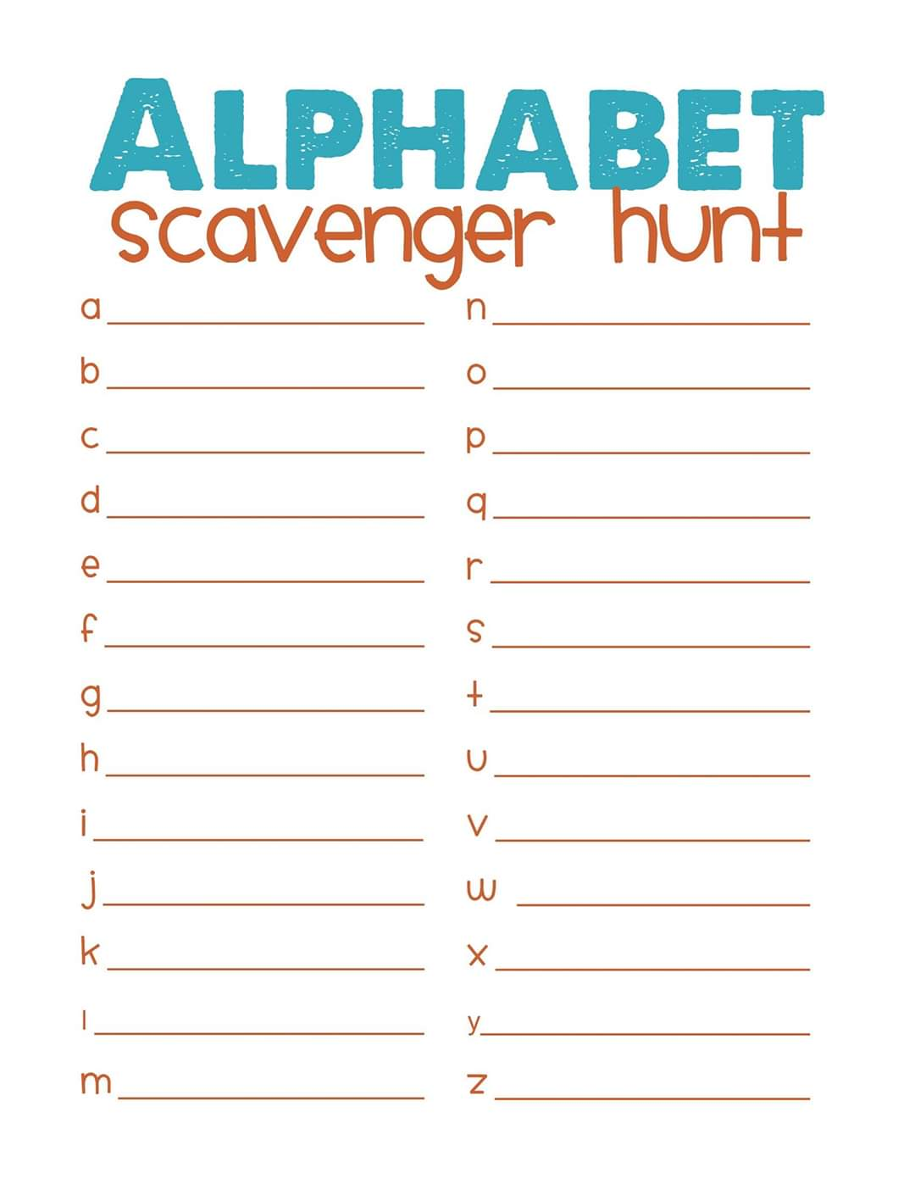
Alphabet Hunt
Taking some paper and a pencil, go out in your garden or on a walk.
While out look around, and find something for each letter of the alphabet.
Don’t worry if you don’t fill it on day one, go out again another time to a different place and see if you can add more.

Dream Garden
What would be in your dream garden? Flowers? A swing? A pond? Birds? Use your imagination and draw your dream below.
