Registered Charity: 1131388
Manor After School & Kids Klubs
Family Ideas & Activities
Staying Active & Healthy Edition
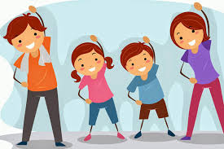
www.maskk.org.uk

This set of ideas, activities and health eating information was put together by Ellen Brookes, a student from Sheffield Hallam University studying BSc Hons Sport and Exercise Sciences. Ellen was on placement at MASKK in February and March 2020 and in her spare time used her experiences from meeting the children across our different projects to research activities they would find interesting.
Staying active and healthy can be a challenge in difficult times but we hope that you find this resource useful, and if so perhaps send some feedback to letsplay@maskk.org.uk that we can share with Ellen and her tutor.
MASKK are a registered charity and rely on grants and donations to continue our work. If you have the means to offer a donation to help us continue our work, please visit our website and click “Donate Today”.
Contents
Children Staying Active 3
Teenagers and Adults Staying Active 5
Gentler & Seated Exercises 6
Sources of Information 8
Eating Well Plan 9

Children Staying Active
(Activities to do with parents’ consent of course)

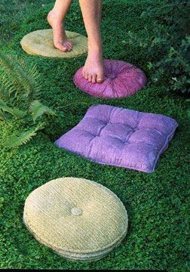
Pillow trampoline
An indoor trampoline alternative could be to take the sofa cushions off and put them on the floor to bounce on!

Stepping stones
Could use sofa cushions or cushions – just anything that can be stood on but also picked up and moved easily. Lay them out in a line (use one more than there are people) then those playing have to stand on a cushion each and move from one place to another without touching the floor by taking it in turns to move forward a cushion then picking up the back cushion and passing it forward and putting it down at the front then moving forwards gain.

High Jump (pillows)
Can use cushions piled up on the arm of the sofa and try and jump over them onto the sofa – could make it a competition with siblings or just try to beat own score.

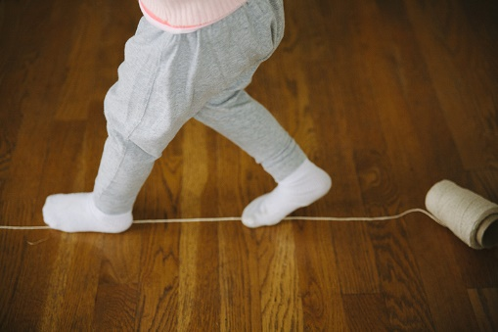
Balance
Find anything that can be balanced on with one leg – could even just be a line on the ground (drawn with chalk or a strip of masking tape) – and try and balance on it. Could see how long you can balance for or see how many times you need to put your other foot down in 30seconds etc. Could be done alone or competition with siblings.

Target
Could be done with a ball and a box and you can try and get it in from different distances or angles. Or could use a balled-up piece of paper and a wastepaper bin, or a pair of socks and a basket. There’s plenty of options for this one, it really just depends what’s around your house!

Dancing
Dancing is a great way to exercise without feeling like you’re exercising. Could always try to learn famous dances from films, pop songs or even YouTube dances if you have it. Feeling energetic? Then YouTube has some fun Kids Zumba to follow too!

Hop Scotch
Classic one to do alone, can use chalk if you have it and space outside or you can use any markings that are on your floor inside. Great fun to do with others.

Speed bounce
All you need for this one is a pillow or something small and soft on the floor and you simply have to jump side to side over it as quick as you can for a certain amount of time. Could be a competition to see who can do the most in a minute or 30seconds.

Vertical Jump
Stand up straight and side on to a blank wall with your arm closet to the wall stretched straight up touching the wall as high up as you can without reaching. Then just have to jump up and touch as far up on the wall as you can with the same hand. The aim is to get the biggest difference between your hand at the start and where you can jump and reach. Works well outside because you can use chalk as a marker if you have it. Can work just as well inside though, just need to mark the points with your hands.

Standing Long Jump
Simply aiming to jump as far as you can from a certain point. Aim to beat your own score or compete with someone else! You can use anything as a marker for the start point and also where you’ve jumped to.

Wall bounce*
If you have a ball that bounces, you can simply throw it against the wall or floor to yourself. Alternatively, you could bounce it to someone else from against the wall – just a bit more interesting if you get bored of catch.

Catch*
Easy one if you have another person to play with and a ball, but you can use anything else as long as it’s not too heavy or hard to catch if you don’t have a ball. Try rolled up socks! If you are alone, you could try throwing it high and see if you can still catch it!

WiiFit/Just Dance/WiiSports*
If you have any sort of video games including a Wii or Xbox with games such as WiiFit, WiiSports or something similar, now is a great time to get it out – can be fun for the whole family. If you have the console but not the games search their app stores for free demo versions too.

Skipping*
Great one if you have a skipping rope lying around, or a dressing gown strap or cut a piece of washing line? – Fun and can be done alone. Try thinking of songs to sing and skills to attempt.

Tag, Stuck in the mud etc.
Great games that can be played with siblings if you have a garden to play in.

Teenagers and Adults Staying Active

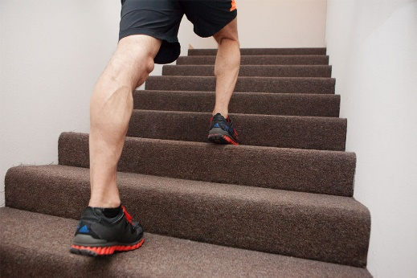
Stairs (3 up 2 down)
A way of incorporating cardio into an at home routine could be to use your stairs, similar to the step machine at a gym. You could try doing 3 steps up and 2 down – or any combination that’s best for you.

Circuits
There are plenty of exercises you can do at the home. Perhaps try creating your own circuit. This could include simple exercises such as sit ups, squats, lunges, press ups etc.

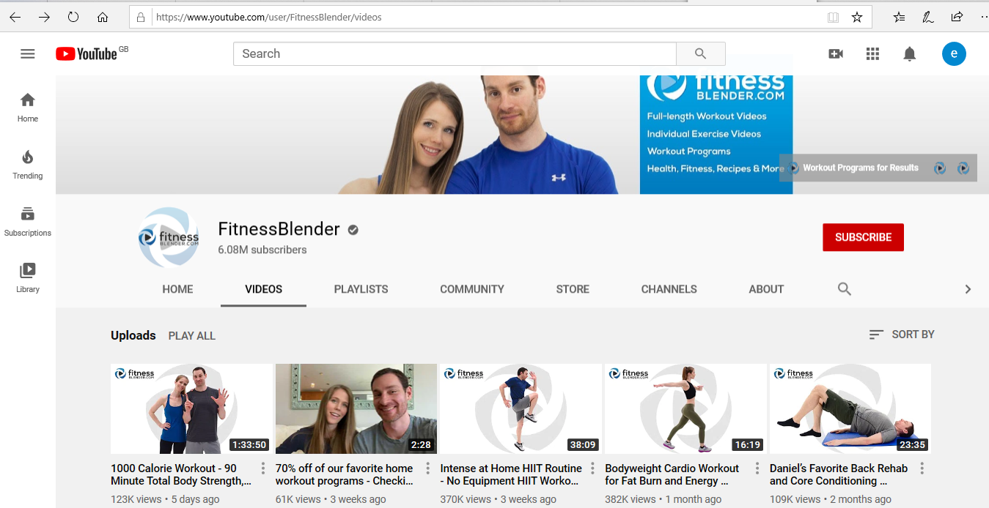
Fitness videos
There are plenty of free at home exercise videos online, particularly on YouTube that you could try. A particularly good one is the FitnessBlender channel on YouTube.

Use tin cans/bottes as weights
If you wanted to add some weight to body weighted exercises you could use tin cans or bottles filled up to the amount you want.

Fitness challenges
There a lots of 30-day fitness challenge apps that you can get on your phone that give different circuits for each day. These are good but sometimes you have to pay for them. Alternatively you can create your own. All you need to do is choose what exercise you wanted to do –for example you just wanted to do squats – you would then start the first day doing perhaps 5 or 10 and then the next day would be a rest day and the day after you’d do 5 or 10 more, depending on what the exercise is and your ability. Then every other day you would add on 5 or 10 extra from the time before, and the day in between are rests. This one requires a bit more thinking about but it gives you something to work for – for example you could aim to be able to do a certain amount of squats and work up to it daily.
But remember the rest days.

Gentler & Seated Exercises

Low impact Aerobics
There are plenty of low impact aerobics videos on YouTube for seniors that you can work out along to which are a great way to get your heart and muscles working. The HASfit channel has some good playlists for low impact workout and the Jenny McClendon channel is good as well.

Lateral Raises
This can be done seated or standing just start with arms down naturally and raise them up to the side at the same time so that your shoulders and elbows make a straight line. This can be done weighted or unweighted.
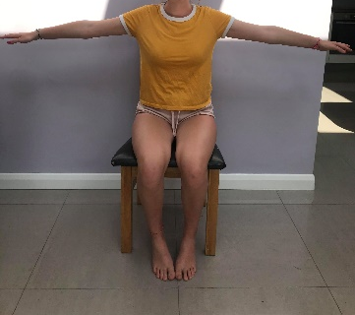
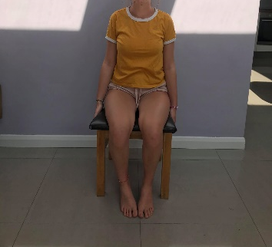

<unweighted

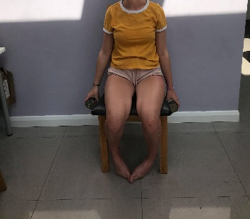
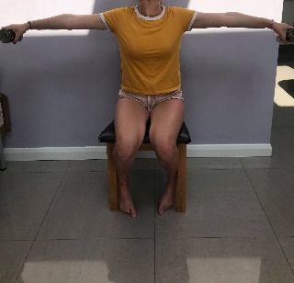

<weighted (using tins or bottles of liquid)

Frontal Raises
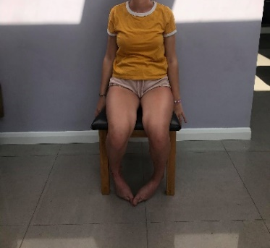
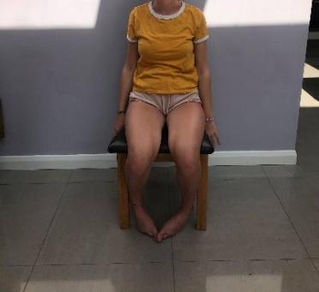
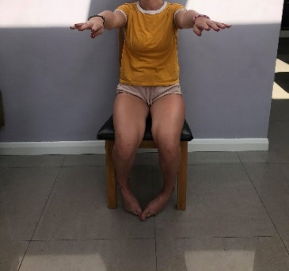
Similar to the lateral raises but instead of your arms going out to the side, you instead bring them up in front of you. Again weighed or unweighted.

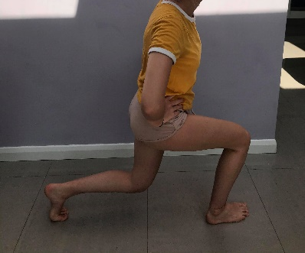
Lunges

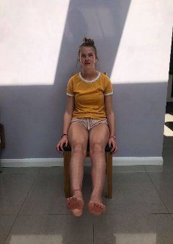
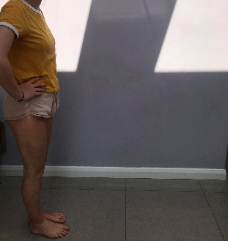
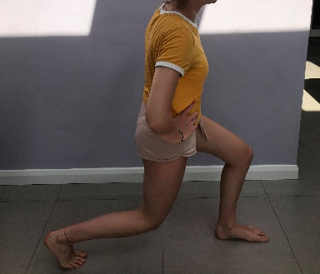
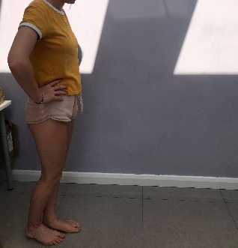
Leg Raises
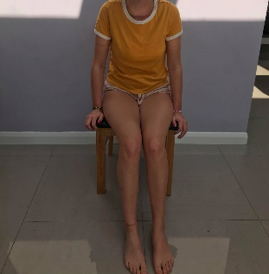
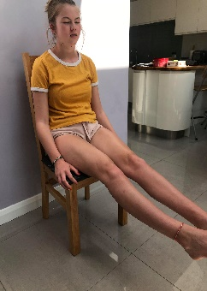
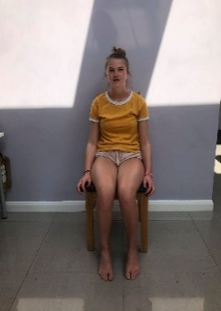
Simply done while sat down, just straight your legs as far as you can in front of you. Hold this for a few seconds then return feet to the floor and repeat.

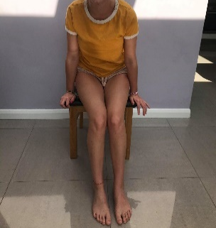
Chair Push Ups
Start seated then use your arms to push yourself up so your bum is no longer touching the chair then lower yourself back down and repeat.

Side step stars
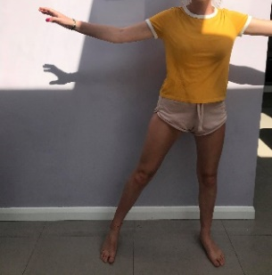
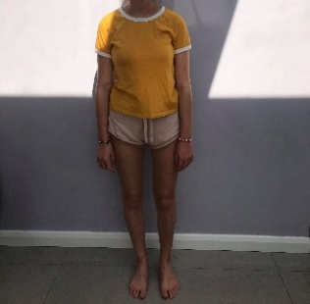
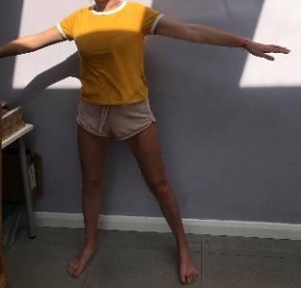
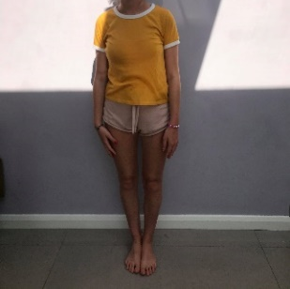
Simply step from side to side, raising both arms at the same time so that your body is in a star shape.

Stand ups
As simple as it sounds, simply start seated and stand up. Sit back down and repeat.

Seated aerobics
For older kids, who would want to do more of a proper work-out type activity rather than games, there are plenty of seated aerobics sessions on YouTube that you can work along to. There are also plenty of upper body exercises that can be done, such as frontal and lateral raises as described above.

Target throw & Catch
As described before but increase the challenge by changing the distance, making a smaller target or throwing a heavier object.

Juggling
Juggling can be a fun skill to try and learn for older kids and is great for coordination. Can also keep you occupied for hours. Easier if you start with something that falls slowly, perhaps like tissues.

Clapping Patterns
If you have a sibling or someone else to play with, then learning or creating your own clapping patterns can be a great way to develop coordination.

Sources of Information
https://www.nhs.uk/common-health-questions/food-and-diet/what-should-my-daily-intake-of-calories-be/
https://www.nhs.uk/live-well/eat-well/what-are-reference-intakes-on-food-labels/
https://www.nhs.uk/common-health-questions/food-and-diet/how-much-sugar-is-good-for-me/
http://theconversation.com/if-sugar-is-so-bad-for-us-why-is-the-sugar-in-fruit-ok-89958
https://www.nhs.uk/live-well/eat-well/healthy-eating-for-teens/
https://www.nhs.uk/common-health-questions/childrens-health/how-many-calories-does-a-child-of-7-10-need/
https://www.healthychildren.org/English/healthy-living/nutrition/Pages/Energy-In-Recommended-Food-Drink-Amounts-for-Children.aspx
http://www.shieldhealthcare.com/community/news/2012/07/10/nutrition-over-70-a-guide-to-senior-dietary-needs/

Eating Well Plan
Don’t force yourself or your children to a calorie restricted life unless instructed to by a doctor, it is better and healthier to focus more on eating healthy foods etc. than worrying too much about the numbers.
The most important part of eating healthy is having a varied and balanced diet.
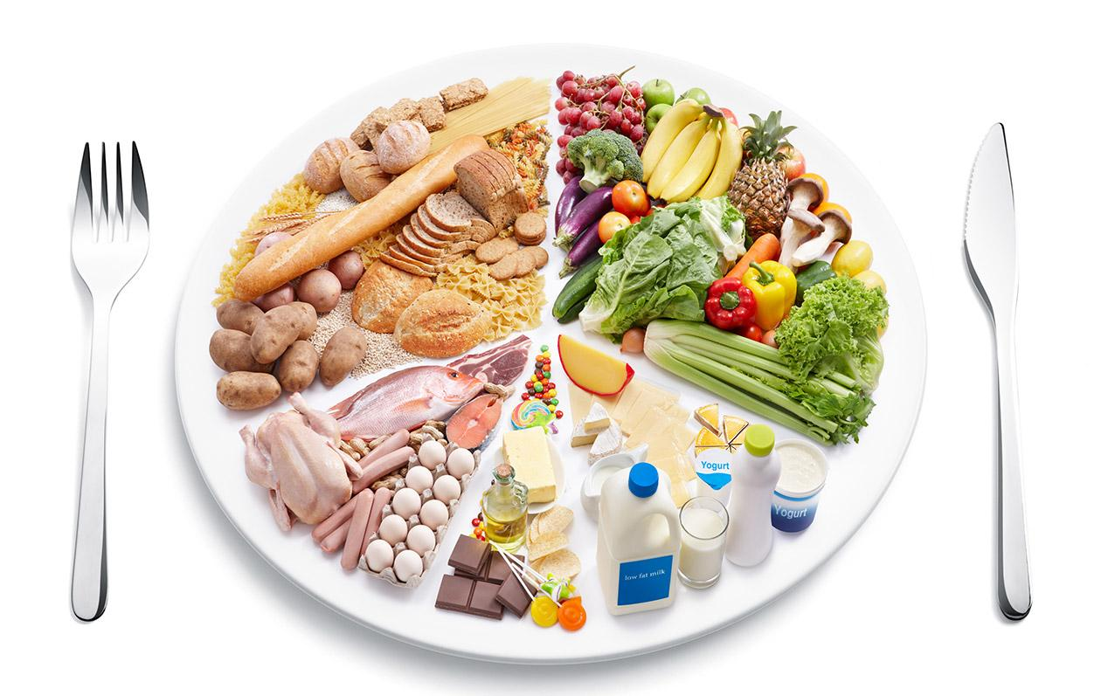
This means ensuring you get enough of each food group.
The first being carbohydrates. This includes everything starchy such as pasta, rice, bread, grain and potatoes and cereals. Carbohydrates are important as they provide energy. The best kind to eat are the more plant based ones, so brown bread and wholegrain pasta etc. as it takes longer for the body to break down and so can provide energy for longer. Try to also pick carbohydrate foods that are high in fiber to help digestion.
Protein is also important, coming from meats, fish, nuts and eggs as they help the body repair itself. Lots of meats etc. can help you get the correct minerals too such as iron and calcium.
Enough fat in your diet is also important however it is important to have the right type. Saturated and trans-fats can lead to many health problems such as high cholesterol levels and heart problems. Therefore, try to swap these out for unsaturated fats, as these provide a good source of energy. High levels of unsaturated fats are found in; avocados, olives, olive oil, peanut (butter/oil), vegetable oils, fatty fish (e.g. salmon and mackerel), nuts and seeds.
It is very important as well to ensure you’re getting enough vitamins to help your immune system. Fruit and veg are great sources of vitamins and you should aim for 5 portions a day (a glass of juice counts as 1 only once a day)
Finally, it is always important to stay hydrated throughout the day by ensuring you’re drinking enough water, especially if you exercise. As a minimum it would be a good idea to have a glass of water with every meal.

Daily intake
Calories are normally used as shorthand for Kilocalories so when looking for calories in food look for what is written as kcal.
Remember: These numbers are all just guidelines to give a rough idea of daily intake and not goals or targets, and they are affected by so many different factors for the individual so it’s important not to get too caught up counting the exact numbers, just use them as what they are - guidelines.
Something to take into account: Unless it says otherwise, the labels on food packages will always show the percentage daily intake for an average sized woman doing an average amount of physical activity, so you or your children may need more or less depending on age/gender/how much physical activity you’re doing.

Children
It is important for children especially to have enough calories as they are generally more active day to day than adults and also their bodies are developing and growing a lot during these early years.
The guidelines are more about body size than age, so it is hard to put an age cap on the ‘child’ guidelines. It would be more beneficial to consider them an adult in this case just when they stop growing as everyone reaches this point at a different age.
Healthychildren.org adapted this table which takes into account activity levels as well, an important factor:

Teenagers
The guidelines are generally the same as that as an adult however, there are certain nutrients that are especially important for teenagers.
Iron – This is important (particularly for girls as they lose iron during their periods) as not enough iron can leave you feeling tired and run down.
Calcium – Important for building strong bones and teeth.
Vitamin D – Good for bone and teeth health, also improves skin and mental health. Mainly from the sun but some foods contain Vitamin D too.
Also especially important to stay hydrated!
These are all important for adults too however in your teen years as you gain independence it is important to instill healthy habits for the rest of your life.
Healthychildren.org has provided average guidelines for teenagers that are activity dependent:

Adults
This table, taken from healthychildren.org gives a suggestion of daily calorie intake that is age, gender and activity dependent:
These are the NHS guidelines for the average adult’s daily intake, breaking it down into specific food groups. All of these numbers (except calories where men have been included) are based on an average sized woman doing an average amount of physical activity in a day:
- Energy: 2,000kcal for women, 2,500kcal for men
- Total fat: less than 70g
- Saturates: less than 20g
- Carbohydrates: at least 260g
- Total sugars: 90g*
- Protein: 50g
- Salt: less than 6g
*Total sugars include sugars in fruit and milk as well as added sugars
These guidelines would differ for the individual as a male would generally need more and if you had a particularly active or inactive day you would need to eat more or less respectively.

Older Adults
Your calorie intake should decrease as you get older, but again that all still depends on how active you are. Shield Healthcare suggests men over 70 need about 2,000 calories per day if sedentary and 2,600 if active while women over 70 should have 1,600 calories per day to 2,000 depending on activity levels.
The oldest category shown on healthychildren.org is 51+ and their guidelines are pretty similar:

Shield Healthcare also suggests that as you get older you should focus especially on ensuring that you get enough fiber, protein, carbohydrates and vitamins and minerals.

Natural sugars in food
A bit of sugar is naturally found in most foods and helps to give you energy. However, it is often also added in excess to processed foods which can accelerate tooth decay alongside other health issues.
When used in foods sugar can be called lots of things so look out for any of the following as added sugar:
- glucose
- sucrose
- maltose
- corn syrup
- honey
- hydrolysed starch
- inverted sugar
- fructose
- molasses
*They could also get away with putting more than one type of sugar on the ingredients list to make it look like there’s less
There is also natural sugars found in fruit and milk, which add to your daily sugar intake. But despite the sugar definitely don’t cut down on these as they are important for a healthy balanced diet. The type of sugar that is found in fruits is only harmful in excessive amounts and you would need to eat A LOT of pieces of fruit to come near that level.
To avoid tooth decay from the sugars in fruit you should try to avoid more than one serving of juice a day and eat that with a meal, as the sugars are released during the juicing process. Despite the natural sugars in fruit you should definitely continue to eat it – aim for 5 a day (and that one is a goal!).
Basically, the type of sugars you need to avoid going overboard on are those added to processed foods, so fizzy drinks, sweets, chocolate, anything like that – no need to cut it out entirely just remember everything in moderation!

